% Romberg integration

clc

clear

close all

%===========input section==================

g = input('Enter the function: ','s');

f = inline(g);

a = input('Enter lower limit, a: ');

b = input('Enter upper limit, b: ');

n=input('Enter number of intervals (multiple of 6)=');

h = b-a;

r = zeros(2,n+1);

r(1,1) = (f(a)+f(b))/2*h;

fprintf('\nRomberg integration table:\n');

fprintf('\n %11.8f\n\n', r(1,1));

%==============loop=================

for i = 2:n

sum = 0;

for k = 1:2^(i-2)

sum = sum+f(a+(k-0.5)*h);

end

r(2,1) = (r(1,1)+h*sum)/2;

for j = 2:i

I = 2^(2*(j-1));

r(2,j) = r(2,j-1)+(r(2,j-1)-r(1,j-1))/(I-1);

end

for k = 1:i

fprintf(' %11.8f',r(2,k));

end

fprintf('\n\n');

h = h/2;

for j = 1:i

r(1,j) = r(2,j);

end

end

%==============graph================

x = linspace(a,b,2^n+1);

y=f(x);

plot(x,y)

title('Plot of RomeBerg Integration Rule');

xlabel('X Axis') ;

ylabel('Y Axis') ;

hold on

for i=1:2^n

plot([x(i),x(i)],[0,y(i)]);

end

**Output**

Enter the function: x.*sin(x)

Enter lower limit, a: 0

Enter upper limit, b: 2.*pi

Enter number of intervals = 6

Romberg integration table:

-0.00000000

-0.00000000 0.00000000

-4.93480220 -6.57973627 -7.01838535

-5.95683320 -6.29751020 -6.27869513 -6.26695401

-6.20223150 -6.28403093 -6.28313231 -6.28320274 -6.28326646

-6.26298595 -6.28323743 -6.28318453 -6.28318536 -6.28318529 -6.28318521

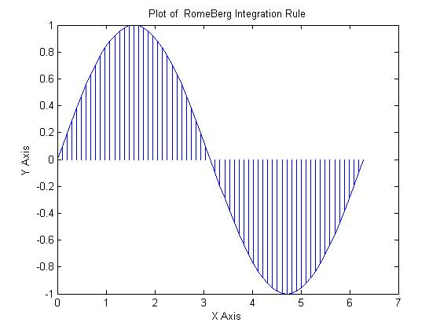

% Trapizoidal Rule

clc

clear

close all

%===========input section==================

g = input('Enter the function: ','s');

f = inline(g);

a = input('Enter lower limit, a: ');

b = input('Enter upper limit, b: ');

n = input('Enter no. of subintervals, n: ');

h=(b-a)/n;

S = f(a)+f(b);

for i=1:n-1

S = S+2*f(a+i*h);

end

I = h/2 *S;

fprintf('The value of integration is %f \n', I);

%==========plot=============

x = linspace(a,b,2^n+1);

y=f(x);

plot(x,y)

title('Bar Plot of Trapizoidal Rule');

xlabel('X Axis') ;

ylabel('Y Axis') ;

hold on

for i=1:2^n

plot([x(i),x(i)],[0,y(i)]);

end

**Output**

Enter the function: 1./(1+x.^2)

Enter lower limit, a: 1

Enter upper limit, b: 20

Enter no. of subintervals, n: 5

The value of integration is 1.202480

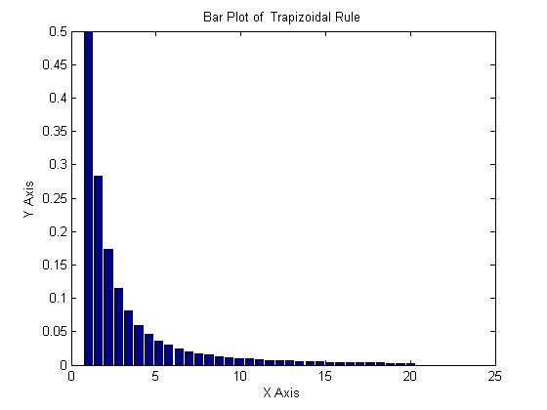

%Simpson 1/3 Rule

clc

clear

close all

%===========input section==================

g = input('Enter the function: ','s');

f = inline(g);

a = input('Enter lower limit, a: ');

b = input('Enter upper limit, b: ');

n=input('Enter number of intervals (multiple of 3)=');

h=(b-a)/n;

x=a:h:b;

sum1 = 0;

sum2 = 0;

for i = 1:n-1

if mod(i,2)==0;

sum2 = sum2+f(a+i*h);

else

sum1 = sum1+f(a+i*h);

end

end

y = h/3.*(f(a)+f(b)+4.*sum1+2.*sum2);

fprintf('The value of y is: %f\n\n', y);

bar(x,y)

title( 'Simpsons 1/3 Rule');

xlabel('X Axis') ;

ylabel('Y Axis') ;

**Output**

Enter the function: 1./(1+x.^2)

Enter lower limit, a: 0

Enter upper limit, b: 20

Enter number of intervals (multiple of 3)=6

The value of y is: 1.602131

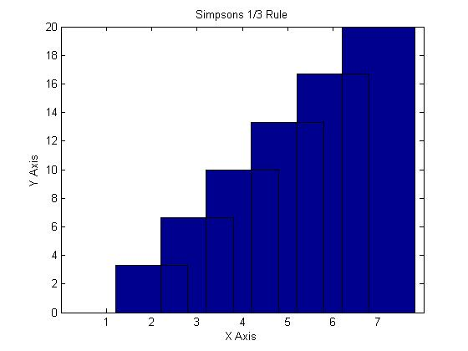

% Numerical Analysis Simpson 3/8 Rule using MATLAB

clear all;

close all;

clc;

g = input('Enter the function: ','s');

f = inline(g);

a=input('Enter lower limit of integral=');

b=input('Enter upper limit of integral=');

n=input('Enter number of intervals (multiple of 3)=');

h=(b-a)/n;

sum1=0.0;

sum2=0.0;

sum3=0.0;

x=a:h:b;

for i=1:3:n-2

x=a+i*h;

sum1=sum1+f(x);

end

for i=2:3:n-1

x=a+i*h;

sum2=sum2+f(x);

end

for i=3:3:n-3

x=a+i*h;

sum3=sum3+f(x);

end

simp=3*h*(f(a)+3.0*sum1+3.0*sum2+2.0*sum3+f(b))/8.0;

fprintf('Integrated value is %f',simp)

bar(x,simp)

title(' Plot of Simpson 3/8 Rule using MATLAB');

xlabel('X Axis') ;

ylabel('Y Axis') ;

**OutPut**

Enter the function: 1./(1+x.^2)

Enter lower limit of integral=1

Enter upper limit of integral=20

Enter number of intervals (multiple of 3)=6

Integrated value is 0.908619

